### **CS23333-Object Oriented Programming Using Java**

**NAME: B. ELUMALAI**

**ROLL NO: 230701084**

# 

# **Lab-06-String, StringBuffer**

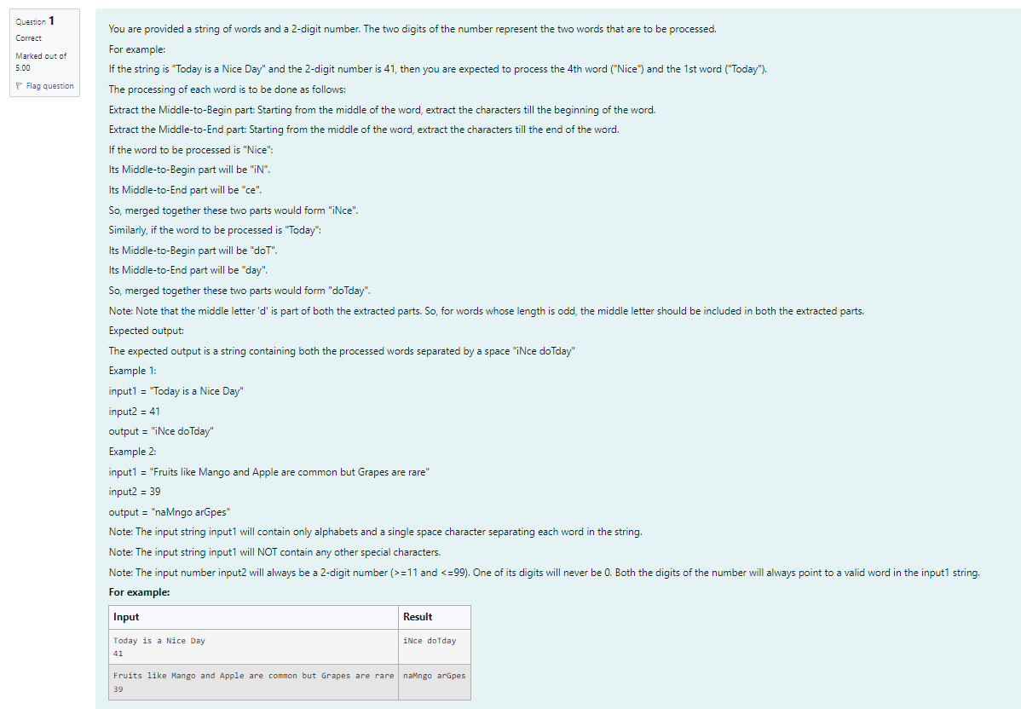

**CODE**

**import java.util.Scanner;**

**import java.util.Arrays;**

**import java.lang.String;**

**class prog {**

**public static void main(String[] args) {**

**Scanner o-new Scanner(System.in);**

**String s=o.nextLine();**

**int n=o.nextInt();**

**String result processWords (s,n); System.out.println(result);**

**}**

**public static String processWords (String input1, int input2) {**

**String[] words input1.split(" ");**

**int firstIndex = (input2/10) 1;**

**int secondIndex = (input2% 10) 1;**

**String firstWordProcessed String secondWordProcessed processWord (words [firstIndex]); processWord (words [secondIndex]);**

**return firstWordProcessed + + secondWordProcessed;**

**}**

**public static String processWord (String word) {**

**int length word.length();**

**int mid length / 2;**

**String 1, f;**

**if (length % 2 == 0) {**

**f-word.substring(0,mid);**

**f= new StringBuilder(f).reverse().toString();**

**1= word.substring(mid);**

**return f+1;**

**} else {**

**f word.substring(0, mid + 1);**

**f= new StringBuilder(f).reverse().toString();**

**1= word.substring(mid);**

**}**

**return f+1;**

**}**

**}**

**OUTPUT**

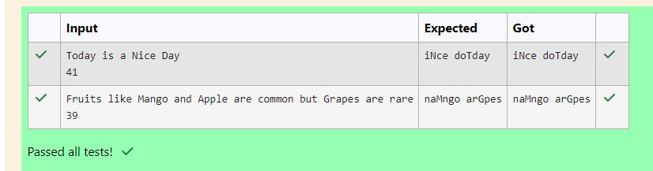

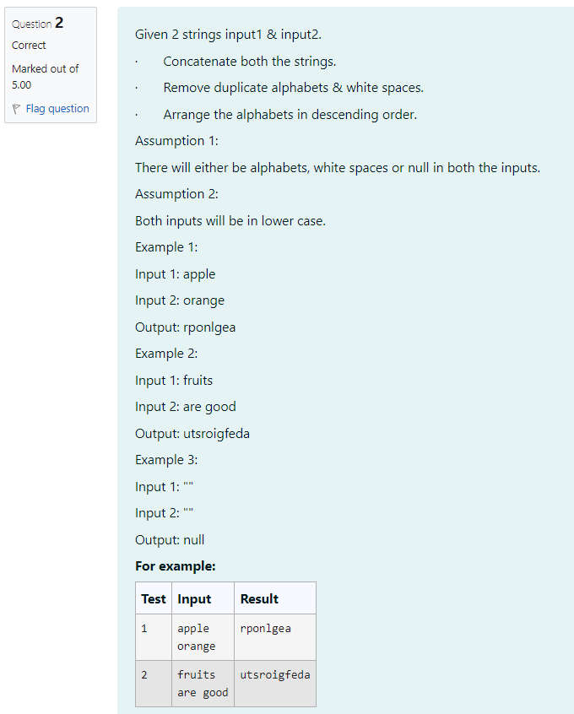

**CODE**

**import java.util.*;**

**public class s {**

**public static String solve (String a, String b) {**

**if ((a== null || a.trim().isEmpty()) && (b null || b.trim().isEmpty())) return "null";**

**String combined a+b;**

**Set<Character> uniqueChars new HashSet<>();**

**for (char c combined.toCharArray()) {**

**if (Character.isAlphabetic(c)) {**

**uniqueChars.add(c);**

**}**

**}**

**char[] charArray new char[uniqueChars.size()];**

**int i = 0;**

**for (char c uniqueChars) {**

**charArray [i++] = c;**

**}**

**Arrays.sort(charArray);**

**return new StringBuilder(new String(charArray)).reverse().toString();**

**}**

**public static void main(String[] args) { Scanner SC new Scanner(System.in);**

**String input1 sc.nextLine();**

**String input2 sc.nextLine();**

**System.out.println(solve(input1, input2));**

**}**

**}**

**OUTPUT**

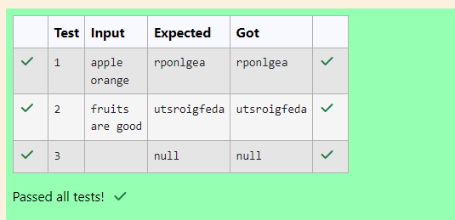

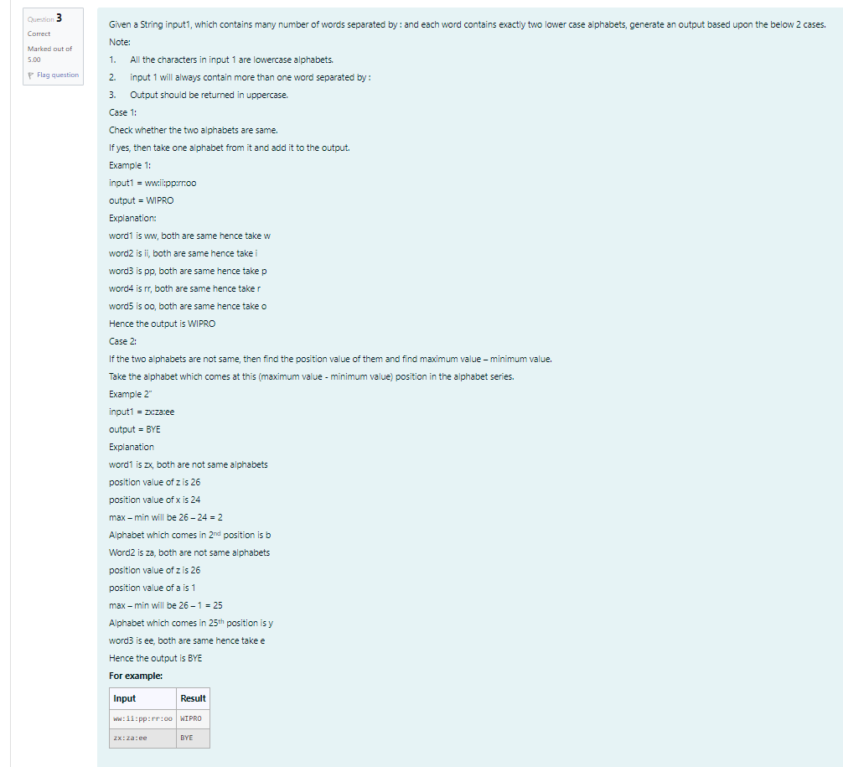

**CODE**

**import java.util.Scanner;**

**public class prog{**

**public static void main(String[] args) {**

**Scanner sc = new Scanner(System.in);**

**String input = sc.nextLine();**

**String[] words = input.split(":");**

**StringBuilder result = new StringBuilder();**

**for (String word words) {**

**char c1 word.charAt(0);**

**char c2 word.charAt(1);**

**if (c1 c2) {**

**result.append(Character.toUpperCase(c1)); } else {**

**int pos1 c1a + 1;**

**int pos2 c2- 'a' + 1;**

**int diff Math.abs(pos1 pos2);**

**char newChar = (char) ('a' diff 1);**

**result.append(Character.toUpperCase (newChar));**

**}**

**}**

**System.out.println(result.toString());**

**}**

**}**

**OUTPUT**

